<DRAMA-ALERT APP>

<Doreen N Mbugua>

<UMKC Student - Senior>

Revision History
Last User to make Changes | Date | Summary of Changes
D. Mbugua | 02/16/2018 | User Interface
D. Mbugua | 03/15/2018 | Login/Registration active

[This section is optional. Revision history may also be recorded as part of version control.]
At the moment, there are no revisions that have been made to the application.
Table of Contents
Vision Statement 4
Requirements 5
Step #1: Identify Categories of Users 5
Step #2: Create Actor-Goal List 5
Step #3: Identify User Stories 6
Product Backlog 7
[Step #4: Write Use Cases] 8
Sprint #1 12
Review 12
Retrospective 13
Design 14
Coding Standards 15

Vision Statement
The vision of this project is to ensure our users are satisfied with our services and are up to date with the most recent drama, information or news going on near them. For users of all ages who want to keep up with social media trends and drama. Drama-Alert is an app that keeps you in the know on all drama happening around you. This app caters to your likes and unlike most social network and celebrity news, Drama-Alert will focus on providing necessary information according to your interests to keep you in the know. Unlike traditional drama sites like E-Online and BuzzFeed this site will allow users to pick their favorite topics so they can get those updates first .
- Project goals – To successfully keep our users informed on what is going on in the stories they love to hear and more
- Project scope – This project aims to provide update features, recommendations to the user, several topics for the user to pick and follow as they would like.
- High-level features or requirements – Being able to chose topics you want to follow and update recommended stories.

Requirements
The project aims to develop a drama app that will keep you informed on what is going on based specifically on your interests and what you like to hear about.
- Drama-Alert program system shall allow users to browse through relevant stories based on their likes and interest.
- The system shall also recommend stories they may want to follow based on their current interest.
- The system shall send notifications when new stories are updated or added based on the users preference.
- The system shall allow users to save stories they like the most to read now or later.
- The system shall allow users access to all news content with correct login requirements.
- The system shall allow reporters to update stories and provide other reference sites that users can visit
- They system shall keep users information and lists saved based on preferences.

These are some of the core requirements of the Drama-Alert app we intend to fulfill and that will guide us as we make this project. A few more detailed decisions that need to implemented throughout this project are as listed below:
- During login, if a user enters a valid ID but invalid password the system should report this to the user and offer an option to reset password or try again
- There should be a maximum of 5 logon attempts after which the user is blocked until they contact support

Step #1: Categories of Users
This app seeks to have users of all ages who have a basic knowledge or experience in handling social media or news apps and with sufficient knowledge to help them navigate through a web or mobile based interface.
Adults– Adults are typically classified as anyone between the ages of 13 and above. Adults with computer knowledge sufficient to navigate a social network app or a web-based interface for the app.

Step #2: Actor-Goal List
These are goals that have been set in place to help us reach our users expectations as well as to ensure we are building an app that caters to all categories of users who may use it.

Some of the goals are listed as follows:
- Users and customer to see what they will be getting (users and the customer need to be able to review and validate requirements), test and ensure they work as they should.
- The project manager to estimate the cost and schedule for the project sufficiently.
- The project manager to plan the project (that is, create a course-grain release plan and fine-grain iteration plans. Release plans express a tentative schedule for delivering features, iteration plans express a detailed schedule of tasks for implementing the features of an iteration.)
Drama-Alert actor-goal list:
Actor | Goal
Regular User | Browse a list of topics
 | Pick or follow specific topics
 | Get notified when new updates come in
 | Share articles, news bits
Reporter | Create articles and updated
 | Posts relevant information pertaining to news/drama updates
 | Publish articles
 | Sees views and follows
Administrator | Grant authority for news and articles to be posted after verification
 | Revoke access to users who abuse or violate rules

Step #3: User Stories

Our App seeks to make information available for everyone just they way they would like it.
As illustrated below, we seek to make sure our users are updated as they prefer. These are some of the user stories we seek to fulfil:

As a fan of movies, I want to know what movies are coming out so that I can prepare appropriately and make time for them.

As a fan of many YouTube personalities, I want to know what major youtubers are doing so that I may be updated even without watching the long videos if I do not have time.

As a student, I want to know what is going on around me so that I am not left out even when I am on a busy schedule

In general:

As a fan of drama/news /information, I want to know what is going on around me so that I can be up to date and in the know without having to look too far for information.

Throughout this project we estimate some of our stories points as illustrated below. These may change as the project continues and as we continue to grow the app to fit its intended use. The story points as well may change as we discover what areas of the projects require more or less points as a way of estimating the time for project completion based on sprints accordingly.
Allow user to pick topics to follow
Estimated Effort: 5 Story Points
If user finds stories they like, they should be able to save stories and follow progress

Allow user to get basic news and relevant links bases on likes or followed topics and save them
Estimated Effort: 10 Story Points
A user needs to be able to find stories they like and have links to more information about stories and be able to save them to read now or later

Product Backlog
These are based on user stories to help us create an app that best fits their desired use. Below is a starter list of our backlog and the priority at the beginning of this project. This will be updated throughout the project through the status section
The collection of stories makes up our project’s product backlog:

Story ID | Story | Story Points | Priority | Status
S1 | As a user I would like to be able to pick topics I am interested in | 5 | 6
S2 | As a user I would like to subscribe or follow special topics | 10 | 2
S3 | As a user I would like to get notified when news comes in about my favorite topics or breaking news and have access to multiple news stories. | 15 | 3
S4 | As a user I would like to be able to share/save/ have access to important articles | 7 | 2 | Completed  03/18/2018
S5 | Give user easy access to news | 17 | 1 | Completed 2/16/2018
S6 | As a user I want a reliable app | 20 | 4 | In Progress

[Step #4: Write Use Cases]
/*Optional*/
Use cases describe how users will interact with the system. They are an excellent way of capturing detailed functional requirements. The use case below shows the interaction between a user and the system in the specific ways we are planning to build them. This will be a great guide during the app development process and will be updated as progress is made to highlight key areas in clearing up the project requirements.
Use Case:
Title: | Find and subscribe to topics interested in
Use case ID: | UC001
Actor: | Regular User
Description: | This use case describes the system interactions needed to find topics one is interested in and be able to subscribe or follow
Basic Flow:
- This use case begins when a use being able to search for new topics.
- The system responds by showing a complete list of available topics. Topics already followed show up first and can be unfollowed. Topics that have not been followed can be selected and added to users follow list.
- The user can select one of the topics to read through before liking.
- The system shows the selected topic has been read
- The user elects to exit the search function. If they like the story, they may choose to follow.
Alternate Flows:
2a. There are no new stories available on specified topic.
1. The system displays a message that no new stories are available.
3a. The user likes and follows multiple topics
1. All selected topics are added to their profile.
3b. The user wants to unfollow a topic
1. The user can unfollow any topics they are not interested in any more
2. The topics do not appear on their profile
Exceptions:
2. There is a format error in topic
- An error message identifying the article or topic is not working correctly is displayed.
Open issues:
- N/A

Here are some general Drama-Alert rules that should ensure the program is being used as it is supposed to by its user. This is to uphold our standard and act as a reliable medium of news/drama updates.
- Users can add as many topics as they would like to
- Users can unsubscribe to topics and subscribe as they would like.
- Users are not allowed to add or edit stories but can send in recommendations

The system shall be easy to use. A representative user fitting the profile of adult described above without any prior experience with the application should be able to find topics they are interested in and engage easily with the app to within 3 minutes.

Sprint #1
For our second sprint, we will have the below in mind to get our app creation project started
- Making a useful Drama-Alert app logo familiar to all (creation/design/logo)
- Cost of implementation (story points or ideal days) will be determined as project gains motion ( project backlogs)
- Amount and value of new knowledge gained by developing the feature this will be through the new users (feedback program or feature)
- Risks resolved as a consequence of implementing specific features will be updated as the project is in motion and if any are discovered during this time

The Sprint Backlog identifies stories planned for the sprint along with tasks necessary to complete each story. This list also shows what was planned for the sprint and the amount of time it took for it to be achieved.

Sprint Backlog
Story ID | Story / Task | Estimated  Hours | Actual  Hours
S5 | Create layout theme for news app | 2 | 1
 | Get reliable news sources | 2 | 5
 | Design UI | 3 | 3
 | Update libraries | 2 | 2
 | Save and retrieve data | 2 | 3

Review
[Minutes/notes from feature demo (product review).]

Retrospective
What went well? What could have gone better? What lessons did you learn? What do you plan to do differently on the next iteration?

My initial idea and plan for sprint one was to start with the basics. That is get a logo for the app, a general layout idea as well as find news/drama sources for my app. I did some research and came across news api’s that could be used to get news directly from trusted news sources. Having found this information, I plan in the next iteration to add more news resources that may not be listed as an API. I would have to research the above thoroughly.
From this sprint I learnt it is good to have a basic idea of what you are trying to do and try to implement it as you had planned it out. There were some things I had not put much consideration into for example , connecting to firebase to store data for my app. Some libraries had to be added to ensure smooth running. Now with a general idea and feel for what my app will look like, I feel confident to continue working to make it functional.
I also learnt to be careful planning my time. I had allocated many too tasks to be completed during the first sprint but I had to do some research to understand some aspects related to the project. I decided to break up the stories in the next iteration so I do not have too many tasks for an iteration. Moving forward, I plan to spend more time on this project as well as not allocating too many tasks throughout the sprint. I have set up priorities to guide me through the project and once those are done, I can add more functions to my app.

Project velocity:
I planned to complete one story that was worth 17 story points. My project velocity is 17. This was just the general set-up for the app ie getting libraries and general set-up for the general design and appearance of the app.

Sprint #2
For our first sprint, we will have the below in mind to get our app creation project started
- Create Login and Registration Page
- Cost of implementation (story points or ideal days) will be determined as project gains motion ( project backlogs)
- Testing login and registration as well as keeping track of users
- Risks resolved as a consequence of implementing specific features will be updated as the project is in motion and if any are discovered during this time

The Sprint Backlog identifies stories planned for the sprint along with tasks necessary to complete each story. This list also shows what was planned for the sprint and the amount of time it took for it to be achieved.

Sprint Backlog
Story ID | Story / Task | Estimated  Hours | Actual  Hours
S4 | Create Login Page | 2 | 8
 | Create Registration for new users | 2 | 0
 | Update/Save user info – have access to personalized page | 3 | 5
 | Update libraries – new versions of android | 2 | 1
 | Debug and test login/registration feature | 5 | 5

Review
[Minutes/notes from feature demo (product review).]

Retrospective
What went well? What could have gone better? What lessons did you learn? What do you plan to do differently on the next iteration?

My second sprint, I aimed to work on getting a login page set up and a registration portion as well. This is so that users can log into their specific pages and customize it to their preference. Initially, I had assumed it would be really easy to do this task but as I worked on the project, I noticed that this page needed a lot of work. It was necessary to make the page as neat and attractive as possible by adding a variety of views to set it up. After creating a login page, majority of my time was spent working on how to test the page to make sure it was working. I had an issue with my button click listener as I accidentally used the wrong variable name and made my app crash several times. The debugging process took the most time and I was only able to debug the login portion and unable to setup the registration part.
While working on this section, I encountered a change in syntax that took me a while to figure out after I went through several android studio pages that were using incorrect syntax. This error did not appear while writing the code and did not show any errors. However, in the middle of my sprint, android studio also updated and I was forced to go through all files in my program and update the versions of use as the ones I previously had were not functioning correctly hereby updating syntax correctly as well. This took quite some time to correct which went into debugging time
I was not able to complete this sprint but I learnt to allocate my time accordingly and to commit changes to github often. I noticed the only time I could get warnings or errors was when I tried to commit to github. I am not sure why android studio has it that way, but it was overwhelming finding errors/warnings as I tried to commit despite having tested the app multiple times. For the next Sprint, I will have to put in extra hours to complete the remaining portion of this sprint. As I continue to work on the app, I have some extra ideas on how to make it better that I will add to the product backlog as it continues to go down.

Project velocity:
I planned to complete one story that was worth 14 story points. My project velocity is 0. This is because I was unable to complete the registration task on the sprint backlog. This will be bundled with the next sprint to be completed.

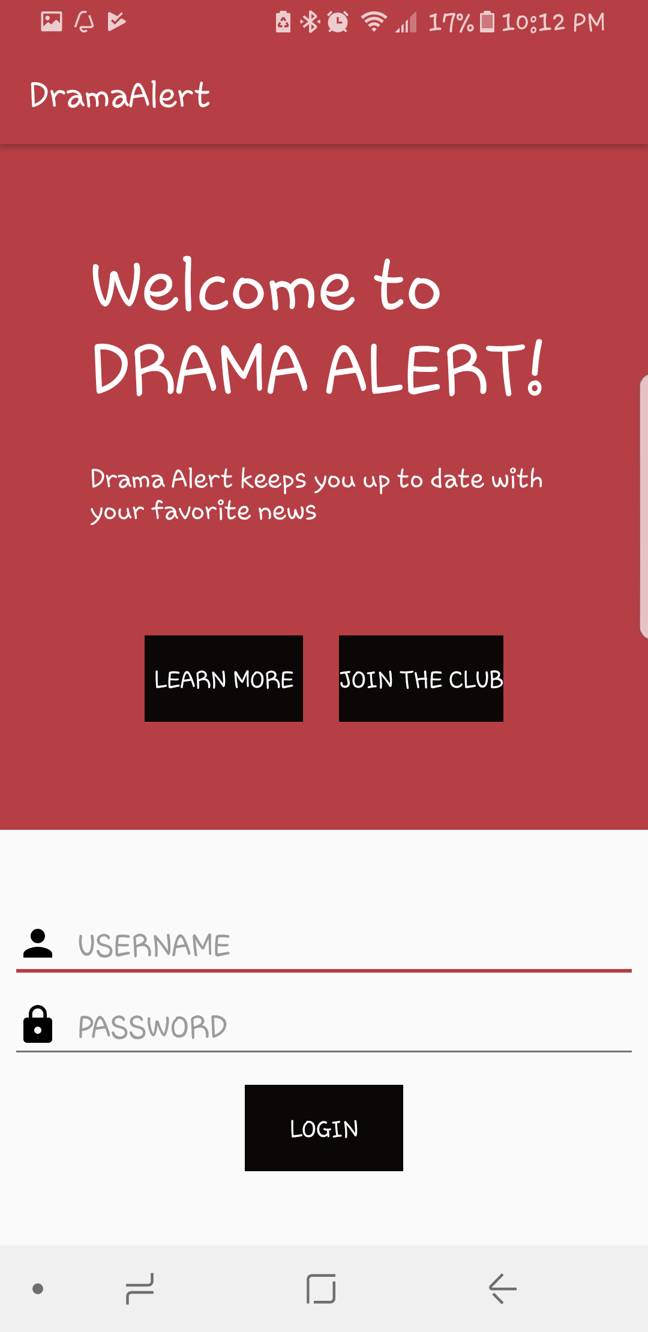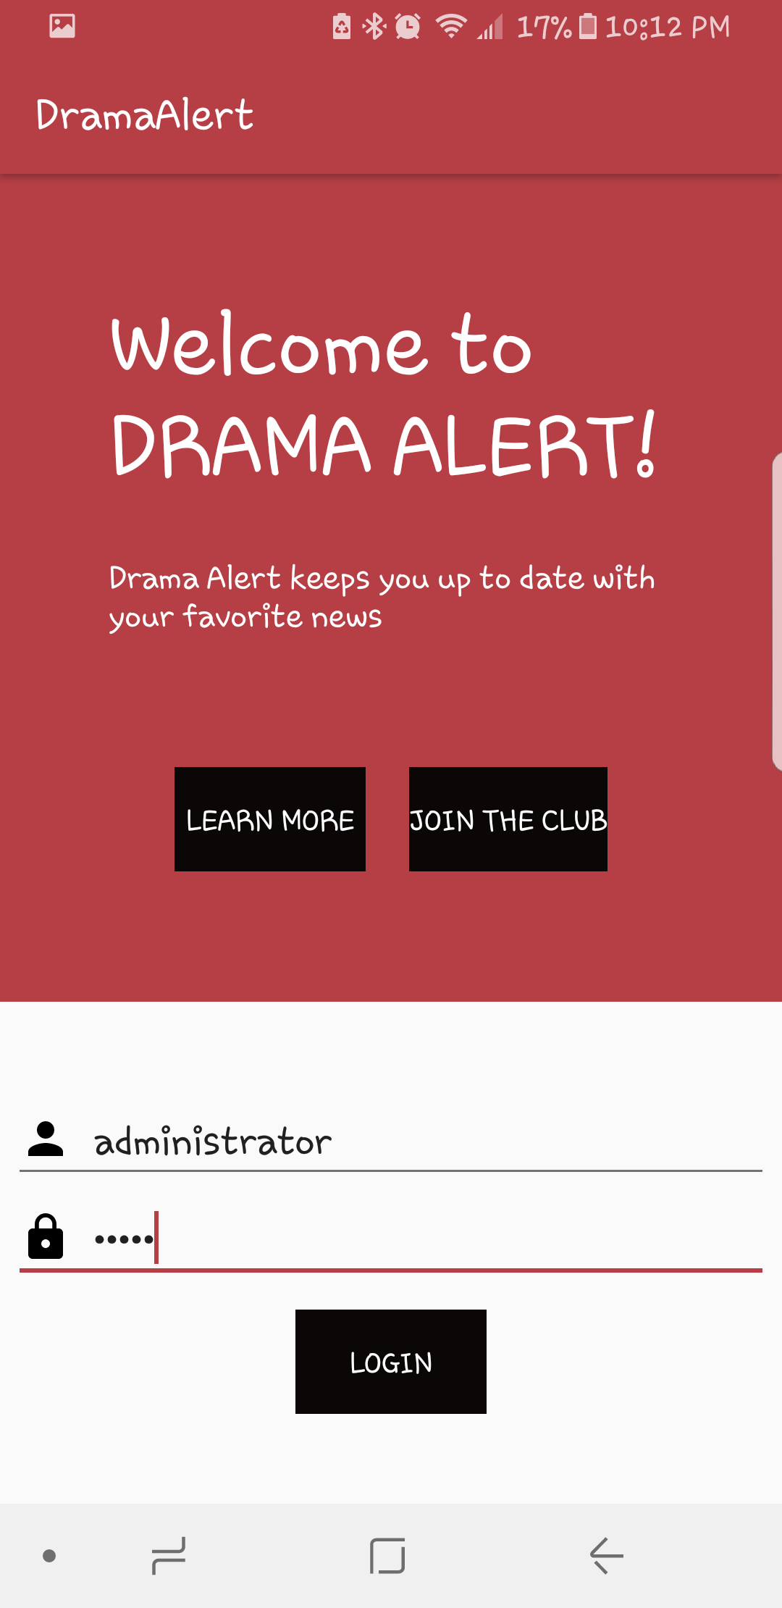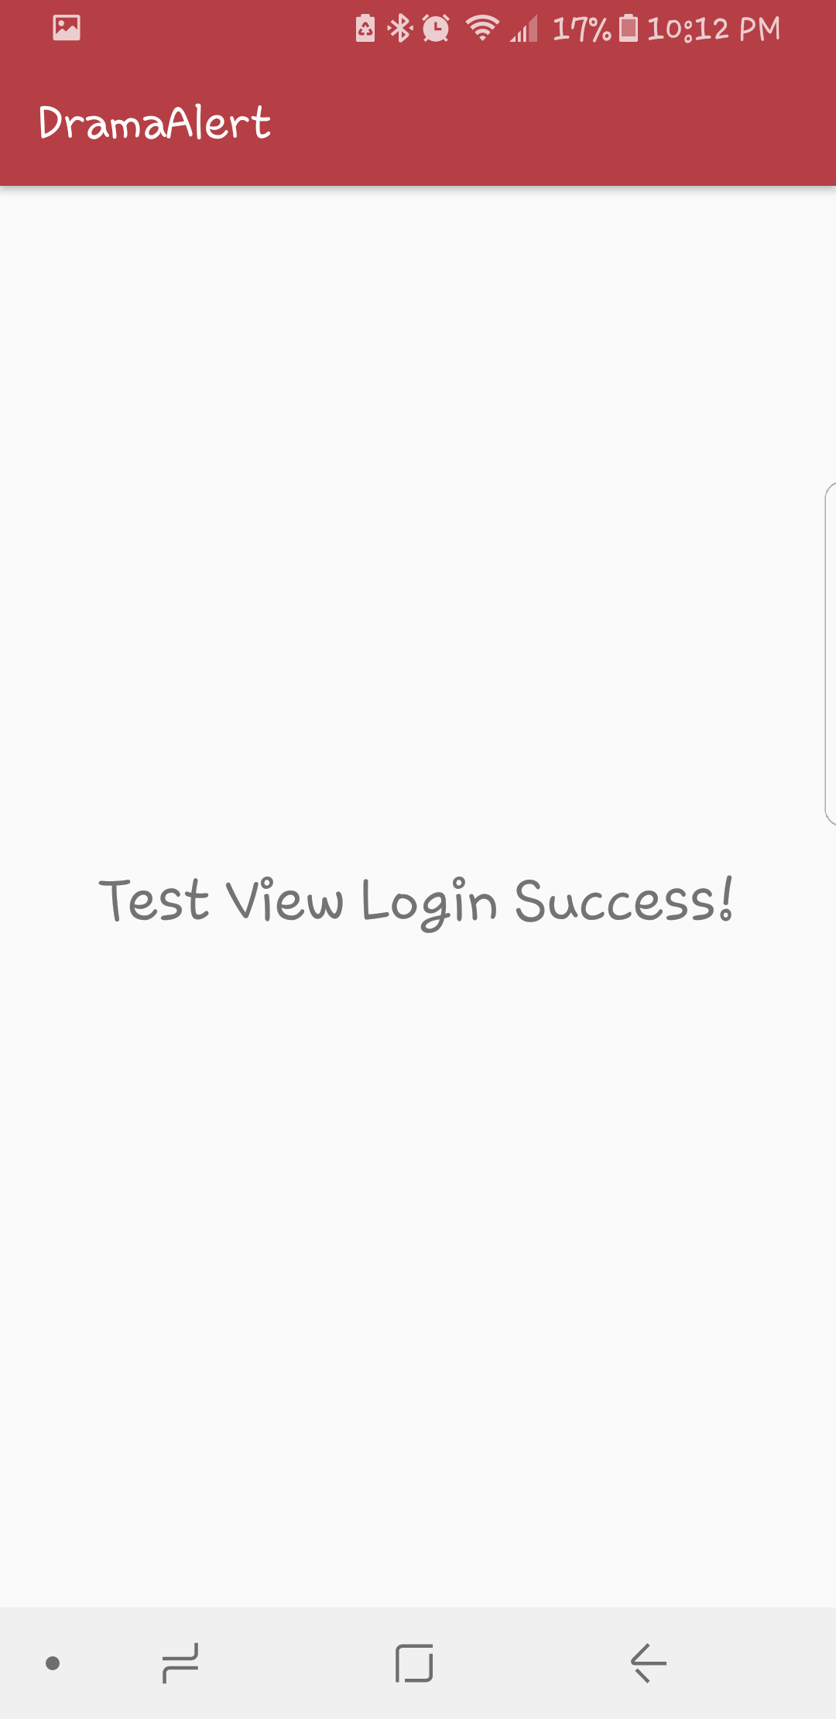

Basic login page including:
Learn More Button
Join the Club Button
Username and Password Login

Administrator is able to login successfully using specified username and password.

Sprint #3
For our first sprint, we will have the below in mind to get our app creation project started
- Finalize Login and Registration Page
- Cost of implementation (story points or ideal days) will be determined as project gains motion ( project backlogs)
- Testing login and registration as well as keeping track of users
- Risks resolved as a consequence of implementing specific features will be updated as the project is in motion and if any are discovered during this time

The Sprint Backlog identifies stories planned for the sprint along with tasks necessary to complete each story. This list also shows what was planned for the sprint and the amount of time it took for it to be achieved.

Sprint Backlog
Story ID | Story / Task | Estimated  Hours | Actual  Hours
S4 | Create Registration for new users | 2 | 8
 | Update/Save user info – have access to personalized page | 3 | 5
 | Update libraries – new versions of android | 2 | 1
 | Debug and test login/registration feature | 5 | 5
 | Add pages for learn more and join the club buttons | 3 | 2
 | Add counter for login (security feature) | 1.5 | 1
 | Store user info | 6 | 8

Review
[Minutes/notes from feature demo (product review).]

Retrospective
What went well? What could have gone better? What lessons did you learn? What do you plan to do differently on the next iteration?

My third sprint, was very interesting. Majority of my research had been done during sprint 2 but I was not able to complete it. It seemed very easy to get a login and register page set up but I had not considered how my app would recognize various people logging in and to prevent incorrect logins. After a lot of research I was able to find a way around it and add a timer to the incorrect passwords so as to provide security for the user.
Although initially having had set up very little time for this activity I noticed that it took a lot of time to do the research as well as to implement. So this item was carried forward from the last sprint and some additional features added to make this section of the program complete for good. I was able to manage my time watching tutorial, doing research and working on the project appropriately. Procrastination was not an option.
I initially had several issues with firebase and getting the information from my app to appear on firebase. It turns out I was actually missing a few lines of code necessary to make firebase work with android studio. Once I fixed this I was able to follow the tutorial and implement working code for my registration portion. Once a user is registered they are redirected to the login page where they can login with their credentials.
I also added a learn more page to tell you more about my app and it has buttons that redirect you to the registration page and login page successfully.
The registration button takes you directly to the registration page. This page will not allow you to leave empty sections eg name, email address or password. This is the only safety measure in place at the moment.

This sprint went a lot better than the last one. I feel I was able to accomplish all the tasks I was hoping and now have a solid foundation for the reminder of the project.

Project velocity:
Sprint 2 had velocity points of 14 that I was not able to complete. I have since completed the sprint 2 and added a few more items on the backlog to complete during this sprint. My project velocity is therefore 30 with all items completed and working properly.

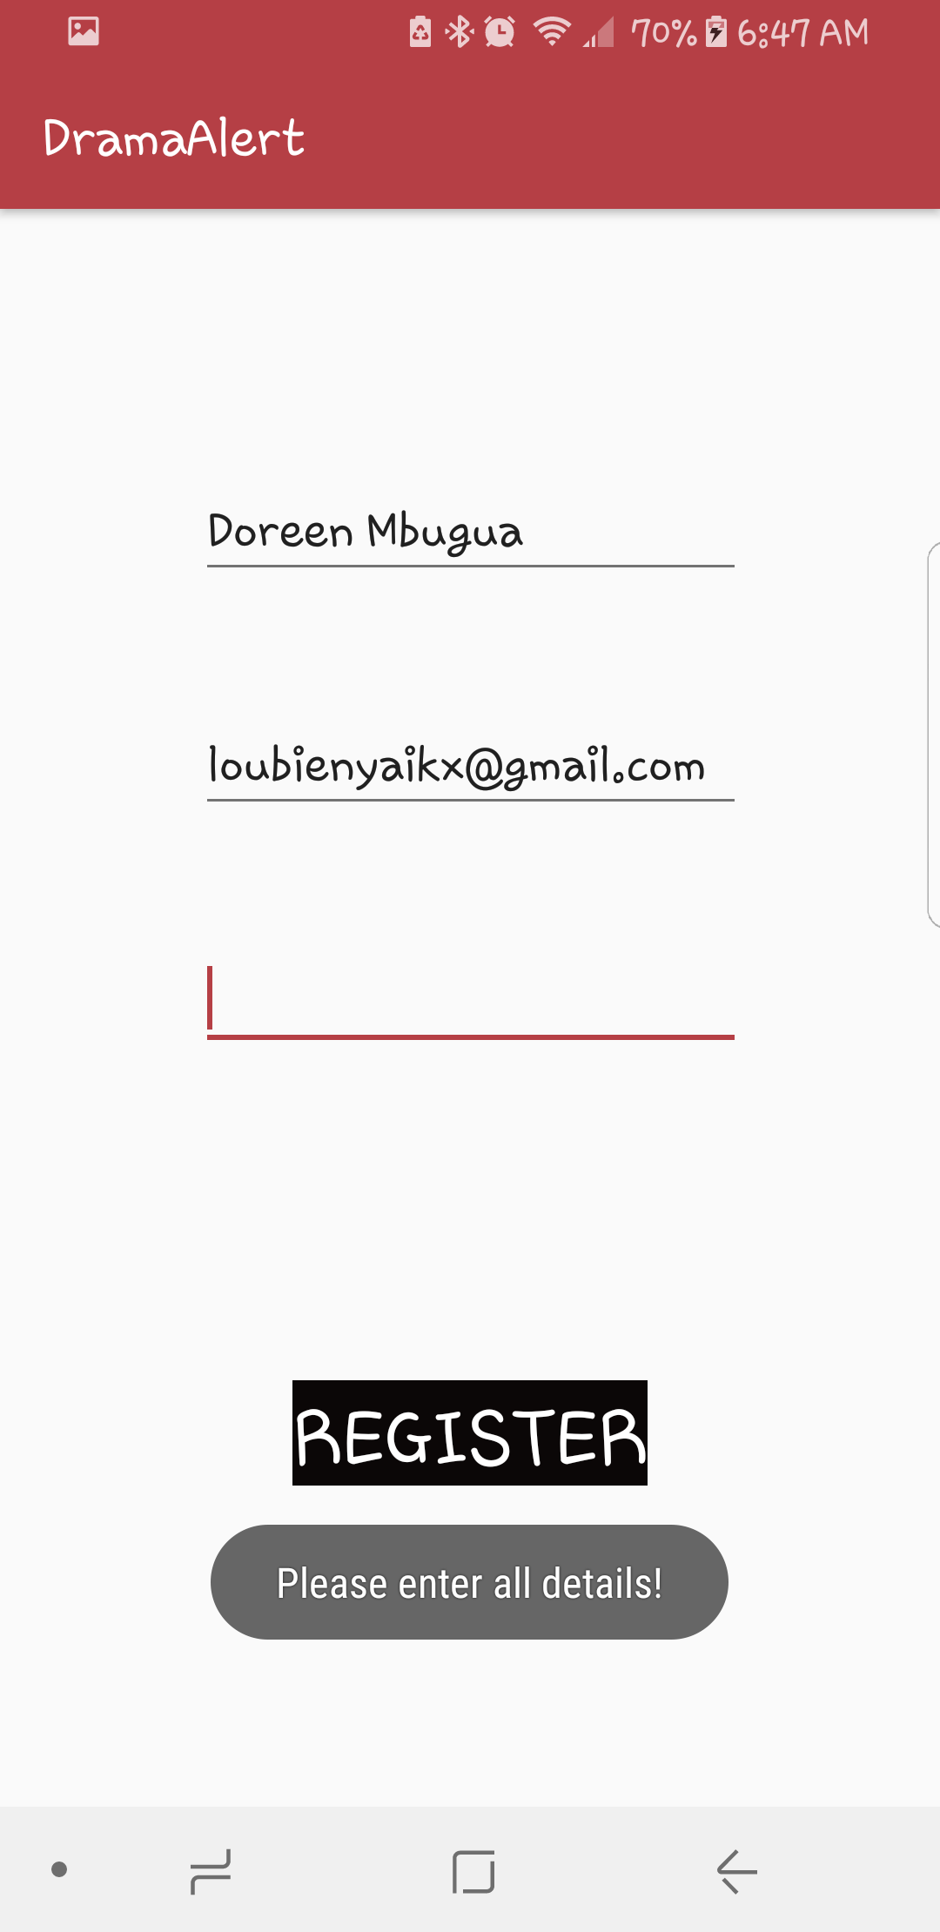
User cannot register without including all required information
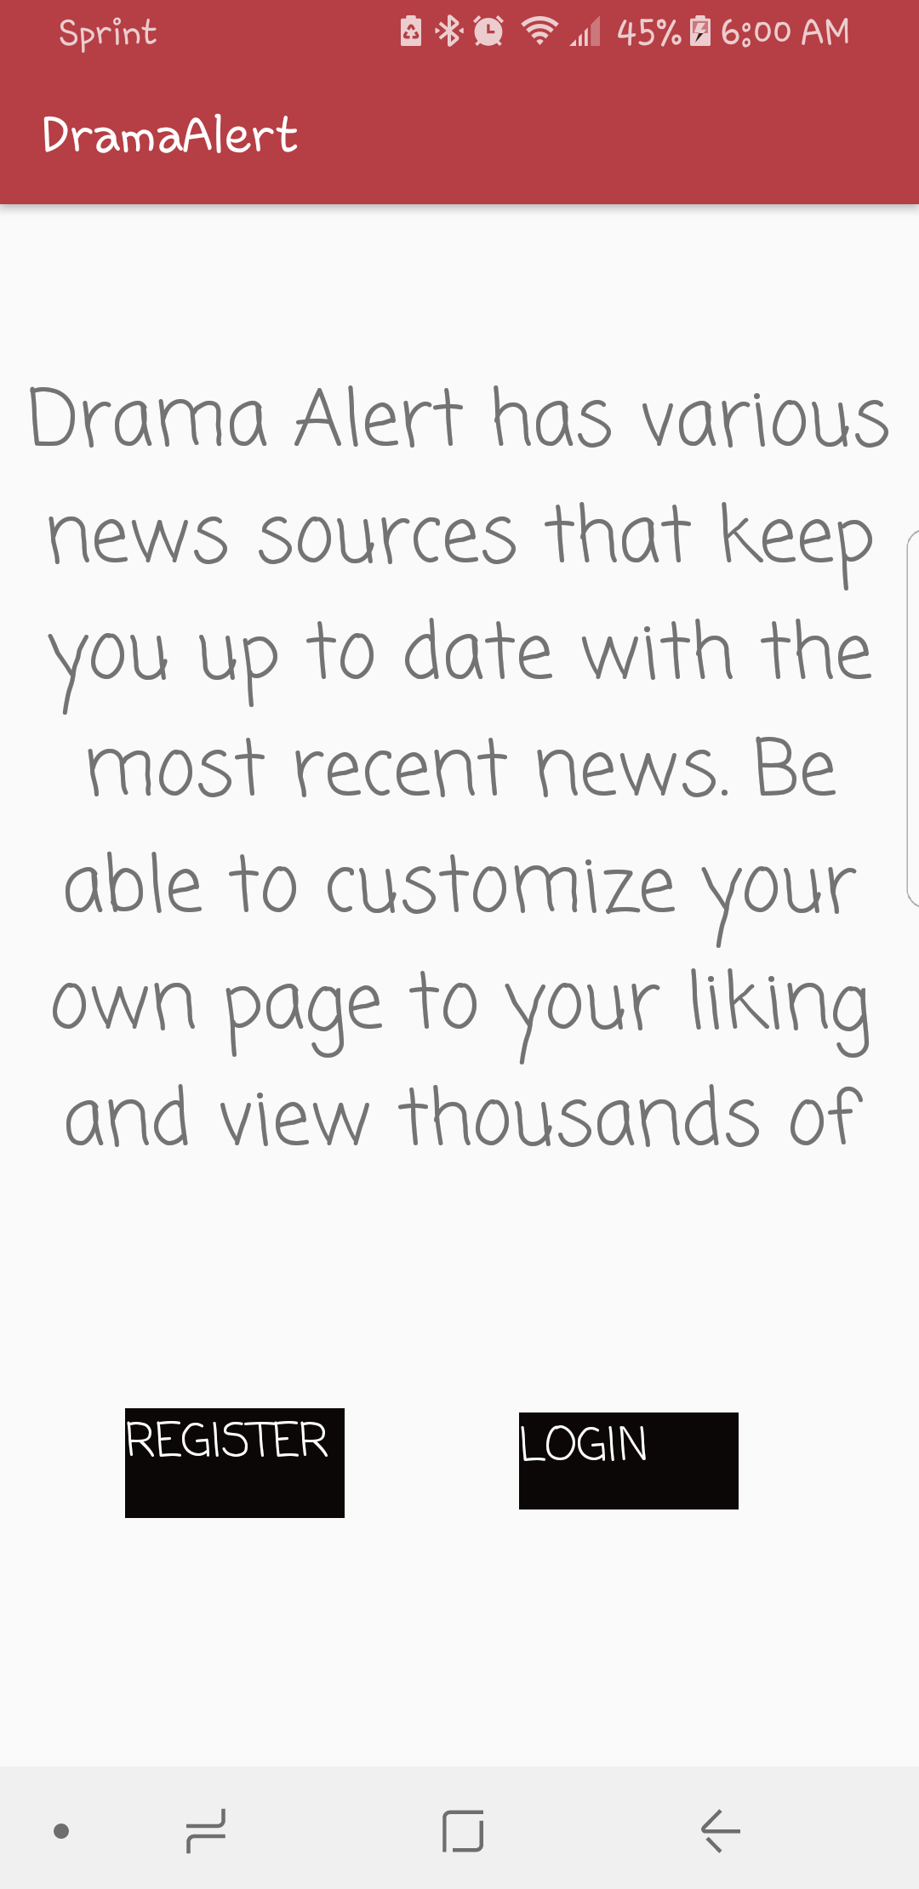 Learn more page with register and login buttons
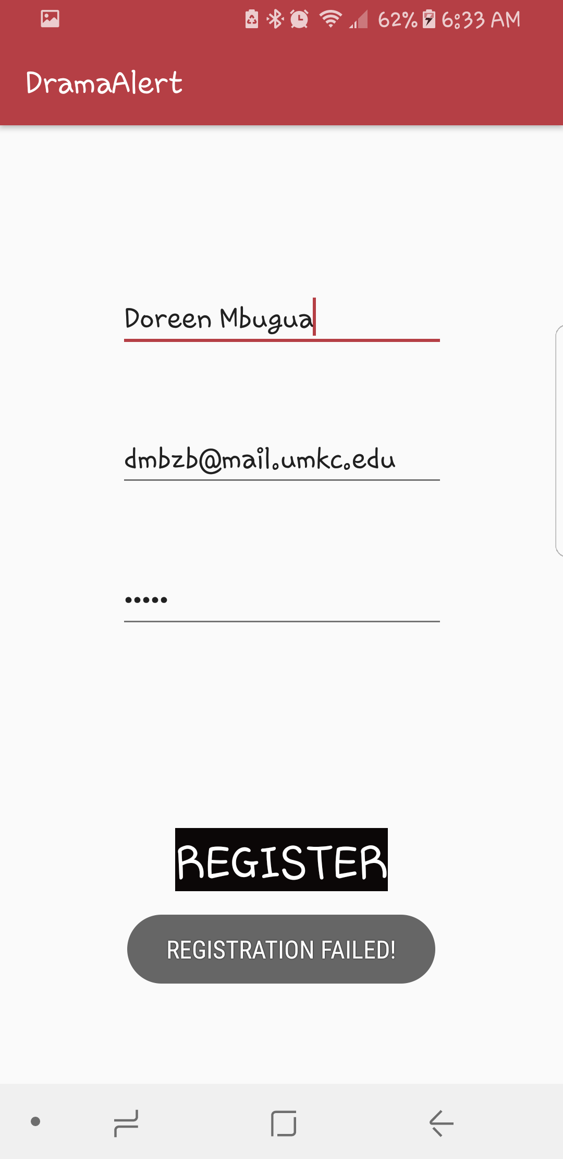 Registration failed – invalid input password
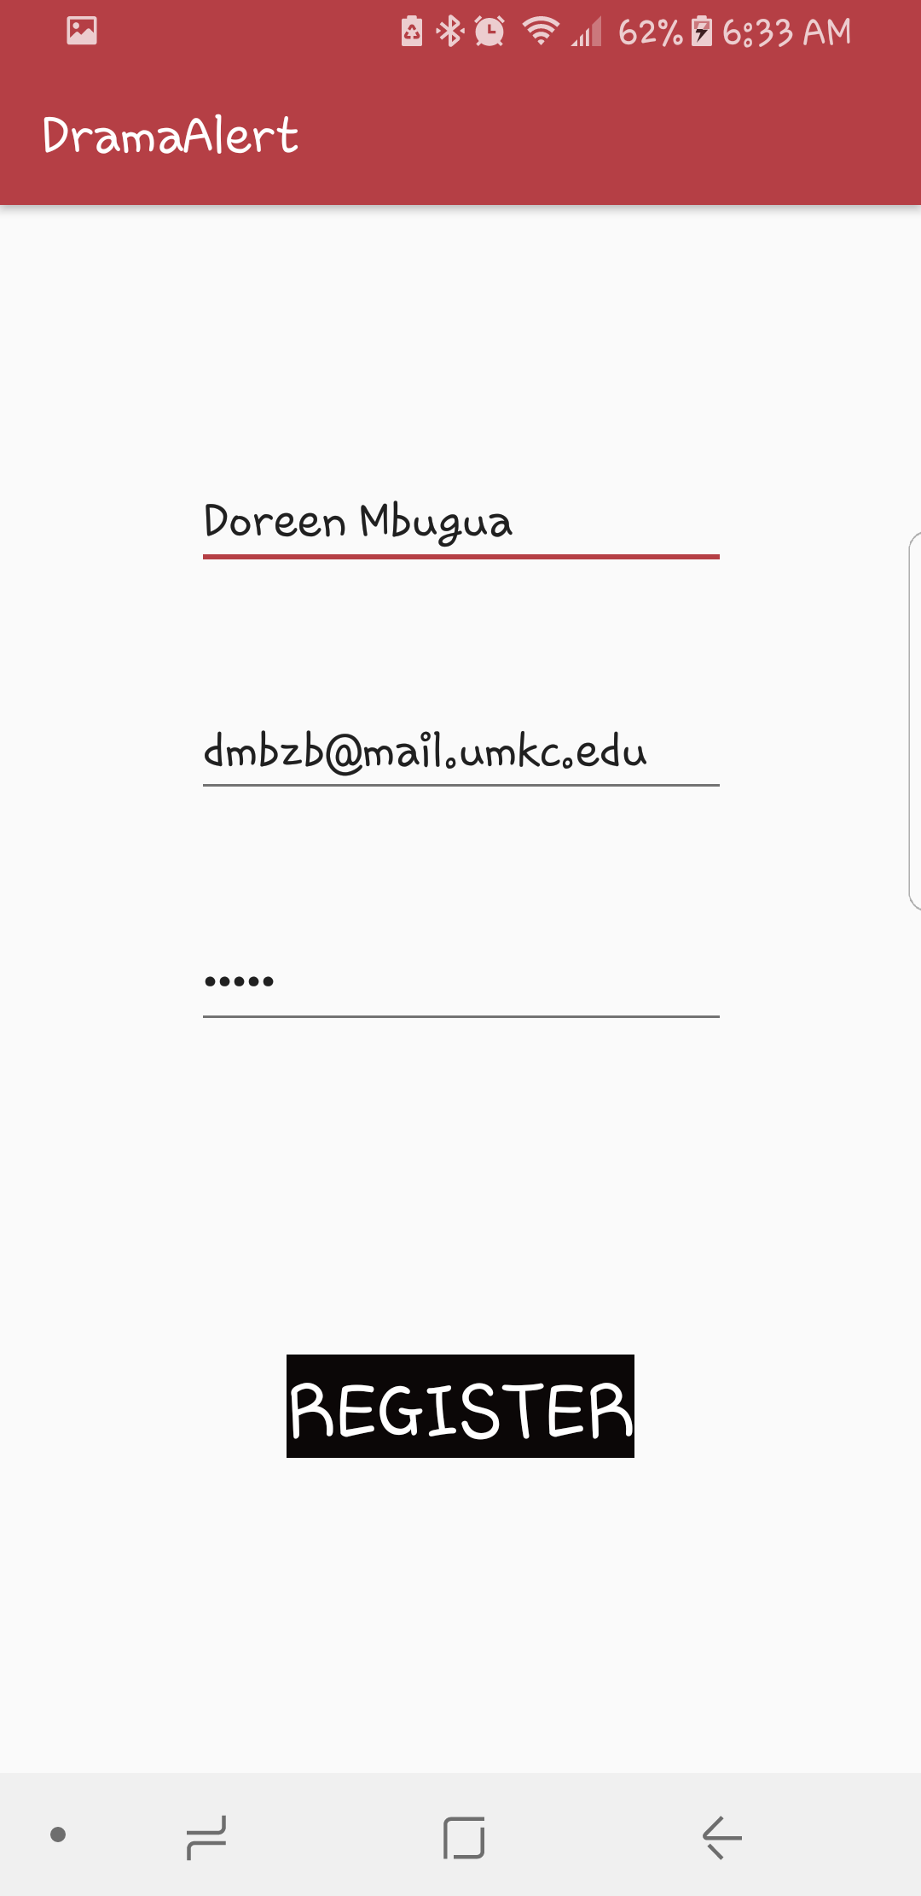 Registration Complete

Sprint #4
For our first sprint, we will have the below in mind to get our app creation project started
- Create multiple access points for news information for my app
- Cost of implementation (story points or ideal days) will be determined as project gains motion ( project backlogs)
- Testing availability of articles and ability for users to save and customize their pages.
- Risks resolved as a consequence of implementing specific features will be updated as the project is in motion and if any are discovered during this time

The Sprint Backlog identifies stories planned for the sprint along with tasks necessary to complete each story. This list also shows what was planned for the sprint and the amount of time it took for it to be achieved.

Sprint Backlog
Story ID | Story / Task | Estimated  Hours | Actual  Hours
S6 | Create test and debug (Refactor) | 4 | 10
 | Keep firebase database updated | 2 | 2
 | Register/login validation | 2 | 2
 | Menu and toolbar | 2 | 2
 | Logout feature | 1 | 1

Review
[Minutes/notes from feature demo (product review).]

Retrospective
What went well? What could have gone better? What lessons did you learn? What do you plan to do differently on the next iteration?

Based on the weeks focus, I changed my planed sprint to accommodate debugging, tests and assertions to make sure all areas were working as required. I had already been debugging so I just had to go through my program looking over various areas I could improve by getting rid of duplicate code and instead using functions that could be called throughout the program. This decreased the number of lines of code making the program more readable. I noticed I had used a lot of code that was significantly similar activities and was able to reduce them into manageable and efficient lines for each activity.
From last weeks sprint, using firebase, I made several changes to validation code and realized I had not accounted for a logout feature on the app. This meant that every time you signed in you would be stuck. I therefore added this to this weeks task as well as adding a tool bar to be extended with any additional features as the program is developed.
Testing cases to validate login was added using Junit. All other info is checked program is running using if else statements to filter out and display accordingly. Test cases need to be general to test the class expectations verses outcomes. At this stage of the project this was only applied to the Login feature. I will however continue to do more research on unit testing and adding onto the program.

Project velocity:

I planned to complete one story that was worth 11 story points. My project velocity is 17. A lot of time was spent going through my code and refactoring it to get rid of duplicate code as well as debugging to take care of some crash reports.

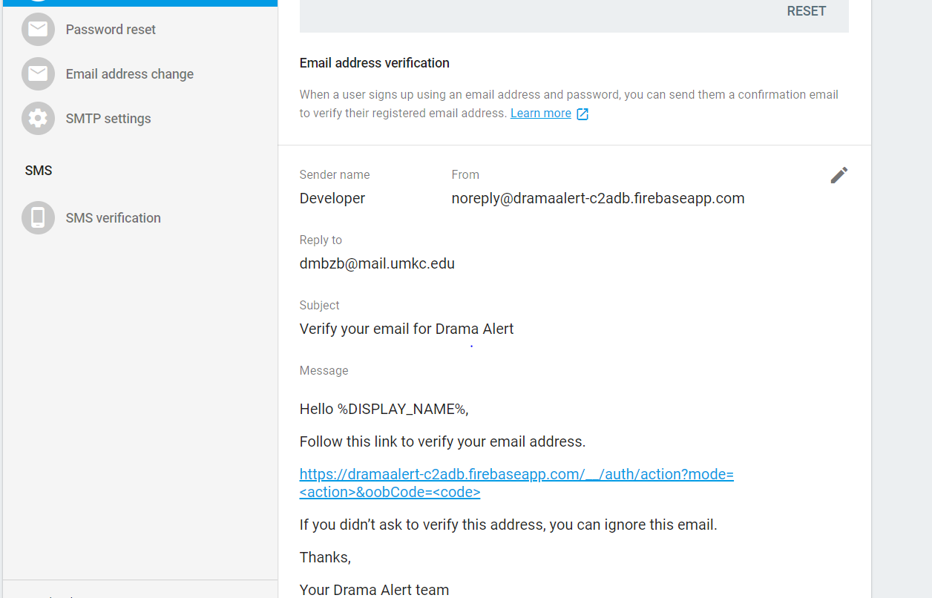
Verification email to be sent once registered 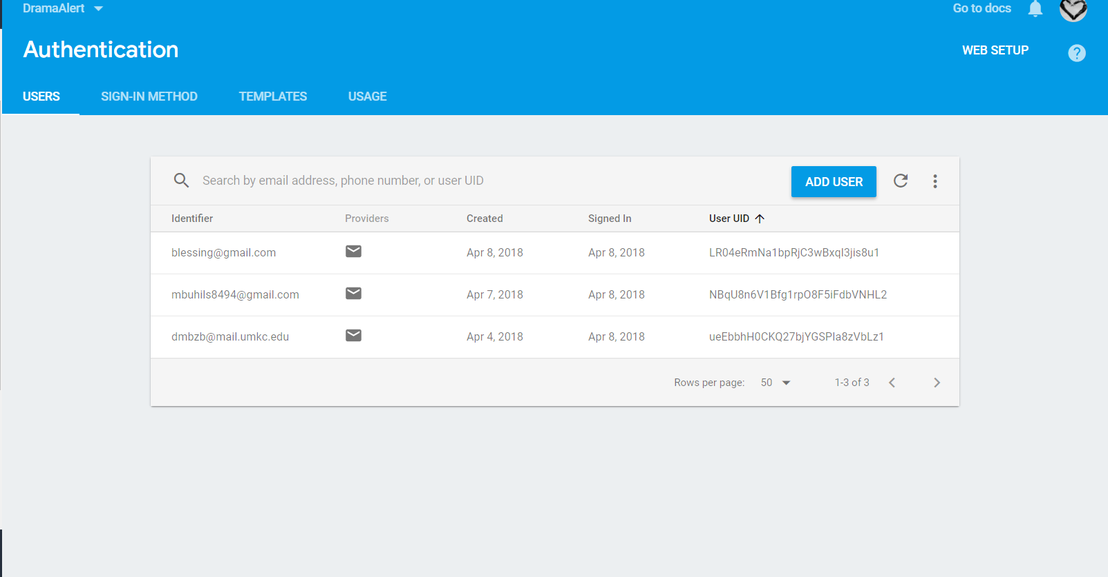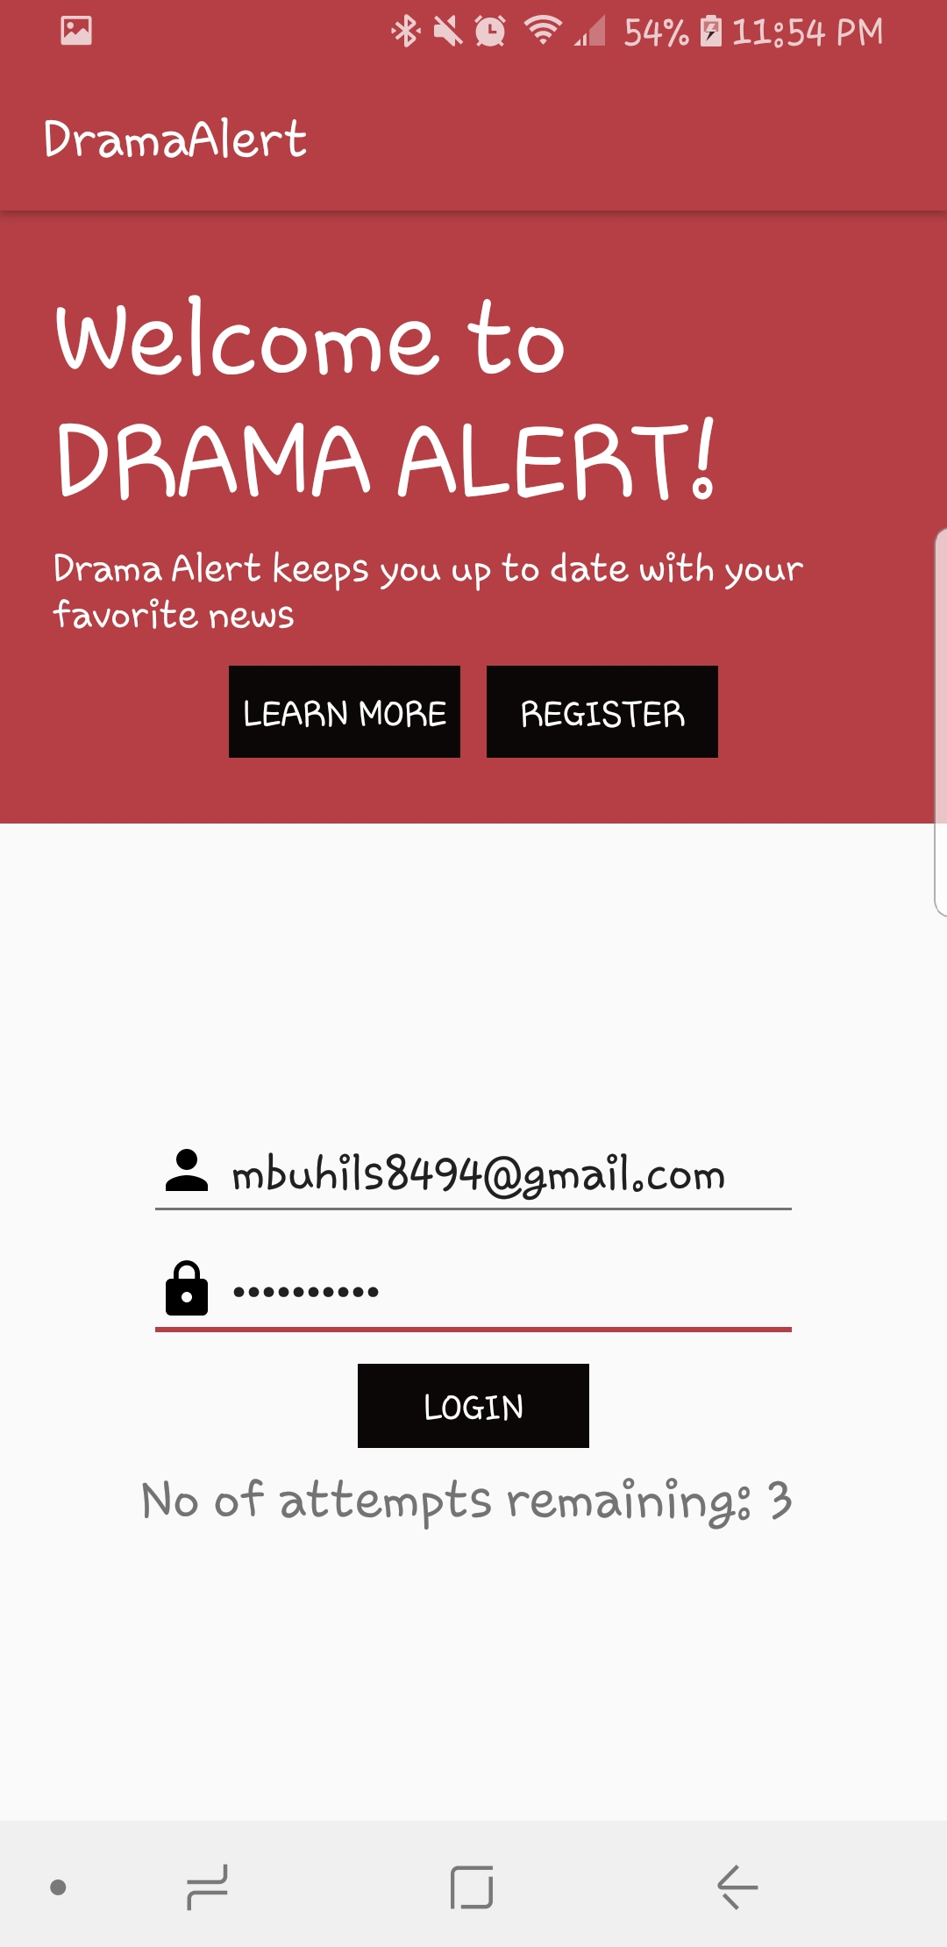
Registered Users and info (firebase)
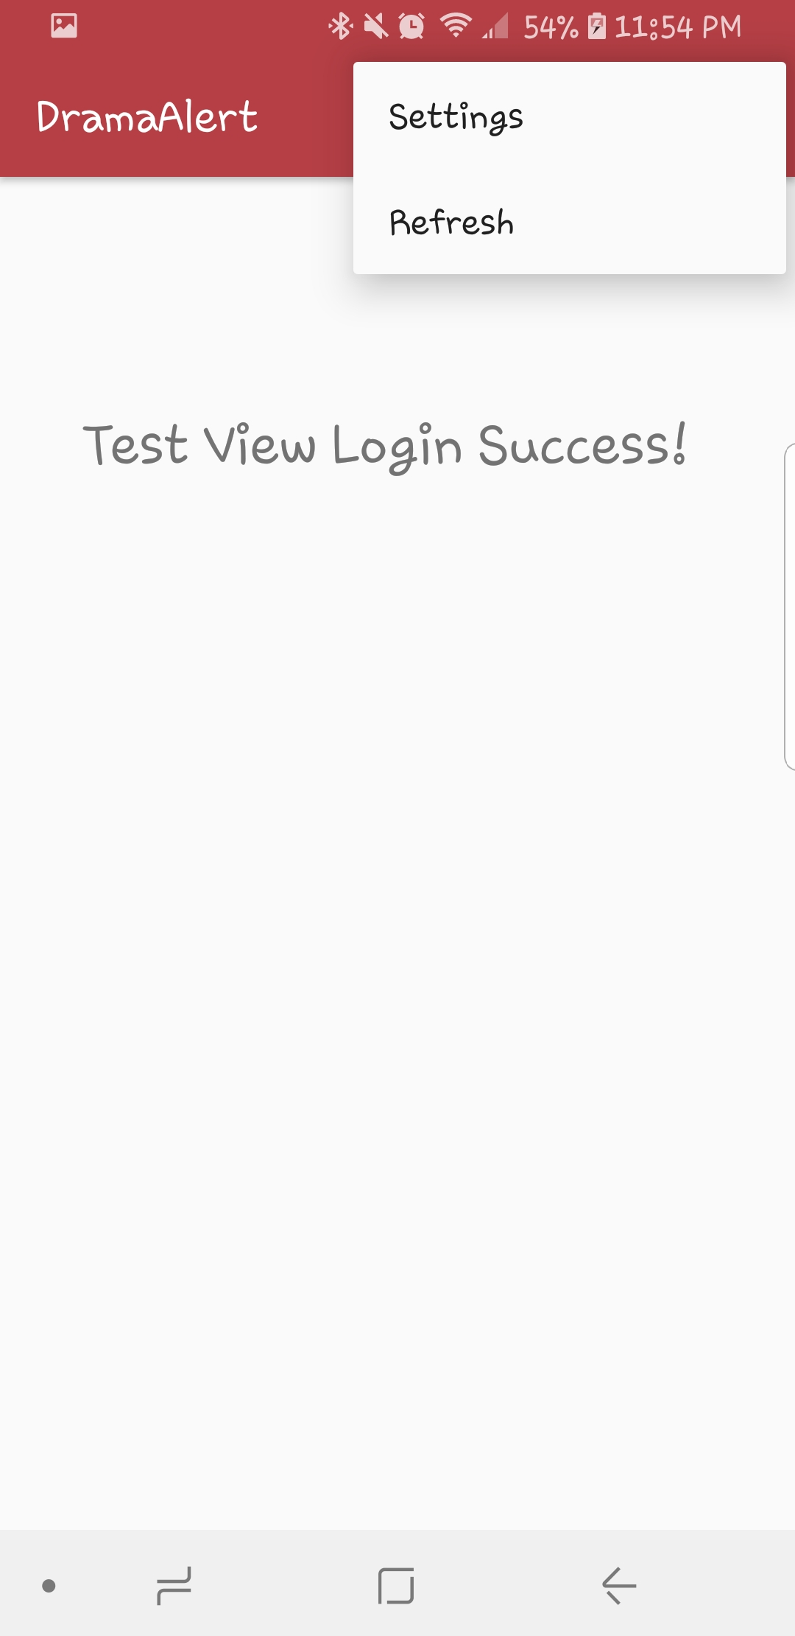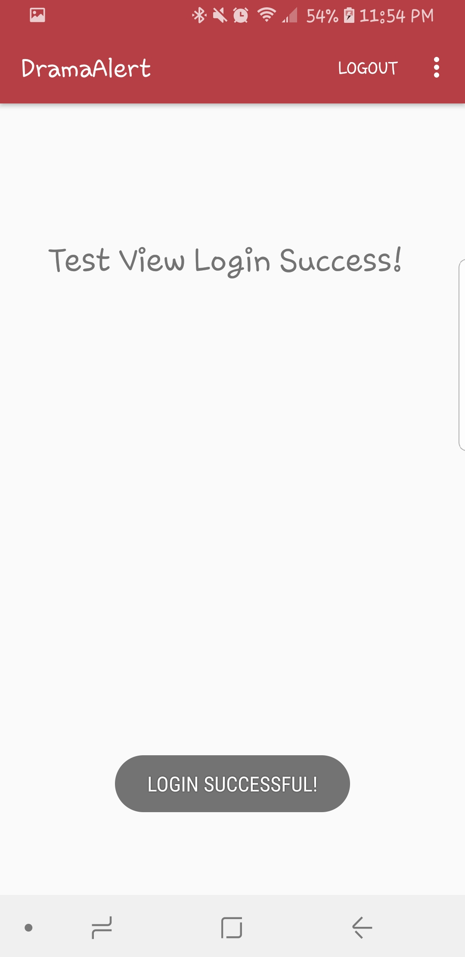
Toolbar Menu Successful login page and logout button

Sprint #5
For our first sprint, we will have the below in mind to get our app creation project started
- Create multiple access points for news information for my app
- Cost of implementation (story points or ideal days) will be determined as project gains motion ( project backlogs)
- Testing availability of articles and ability for users to save and customize their pages.
- Risks resolved as a consequence of implementing specific features will be updated as the project is in motion and if any are discovered during this time

The Sprint Backlog identifies stories planned for the sprint along with tasks necessary to complete each story. This list also shows what was planned for the sprint and the amount of time it took for it to be achieved.

Sprint Backlog
Story ID | Story / Task | Estimated  Hours | Actual  Hours
S3 | Add multiple news APIs | 4 | 22
 | Update/Save user info – saved articles | 2 | 0
 | Add/ remove articles | 2 | 2
 | Add help section | 2 | 0
 | Debug and test | 5 | 15

Review
[Minutes/notes from feature demo (product review).]

Retrospective
What went well? What could have gone better? What lessons did you learn? What do you plan to do differently on the next iteration?

Initially when I started working on this iteration I knew exactly what I needed to focus on. During the first few days I did a bit of research on how I can add some APIs to an android app. It was my aim to have multiple APIs but I decided to start with just one to ensure that it was working correctly. I encountered a problem halfway through the project when I received a new android studio update that did not sync all files correctly. This led to my program crashing initially when I tried to log in and at one point the program would not even start. It took some time to realize that this was because of a sync error and some project files being updated to the latest versions while others still had the previous version. Several import statements and compile statements had been changed and needed to be updated in order for the program to run correctly. Once I realized this it was quite an easy fix. It did however take a long time to get there.
I was able to successfully add a BBC news AP to my app and display several details through my firebase database. I encountered a useful tool called Zapier that helps automate the process of adding new files to my add through firebase. This was easy to set up and will be fully implemented in the last iteration.
At the moment, I have a bug I cannot seem to fix, whenever I run my app, it gets stuck on the loader screen and does not load any news articles. Although I can see the articles in my database loading, they are not being transferred to my app. This is my biggest challenge in my goal towards finishing my application
My aim is for the last iteration is to fix this issue and to build up more reliable news sources and keep track of viewed or liked stories

Project velocity:
I planned to complete one story that was worth 15 story points. My project velocity is 0. I was unable to successfully complete the task. The app has a bug that needs to be fixed. I realize now that I allocated a lot less time to items that required a lot of time and research beforehand. Despite this, I am confident I know how to fix this problem and since I have done most of it, the final iteration will be successful and complete.

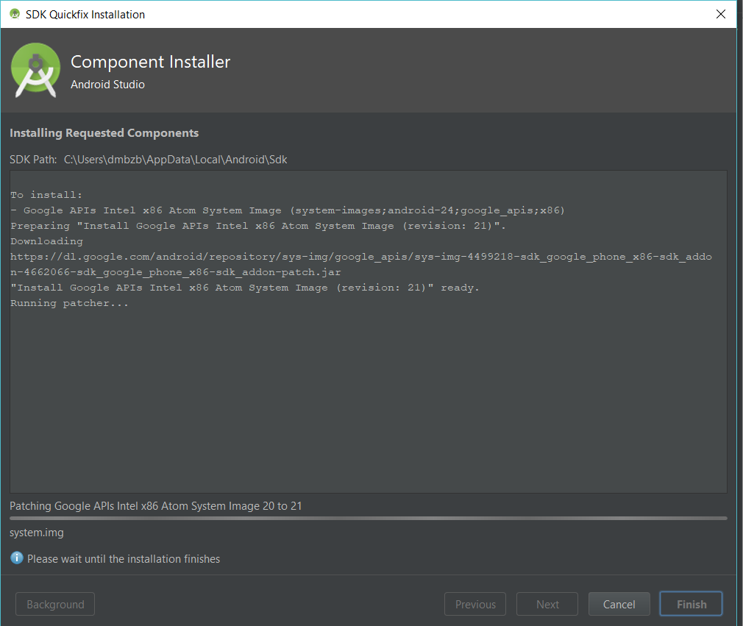
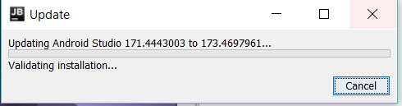

Updates to android studio/ implementation 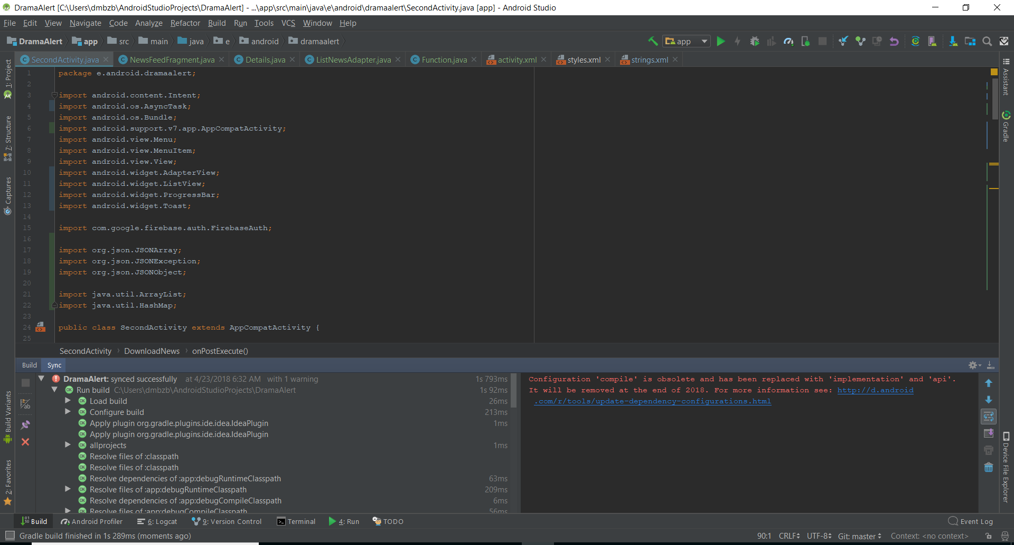
Sync errors and changes to android studio
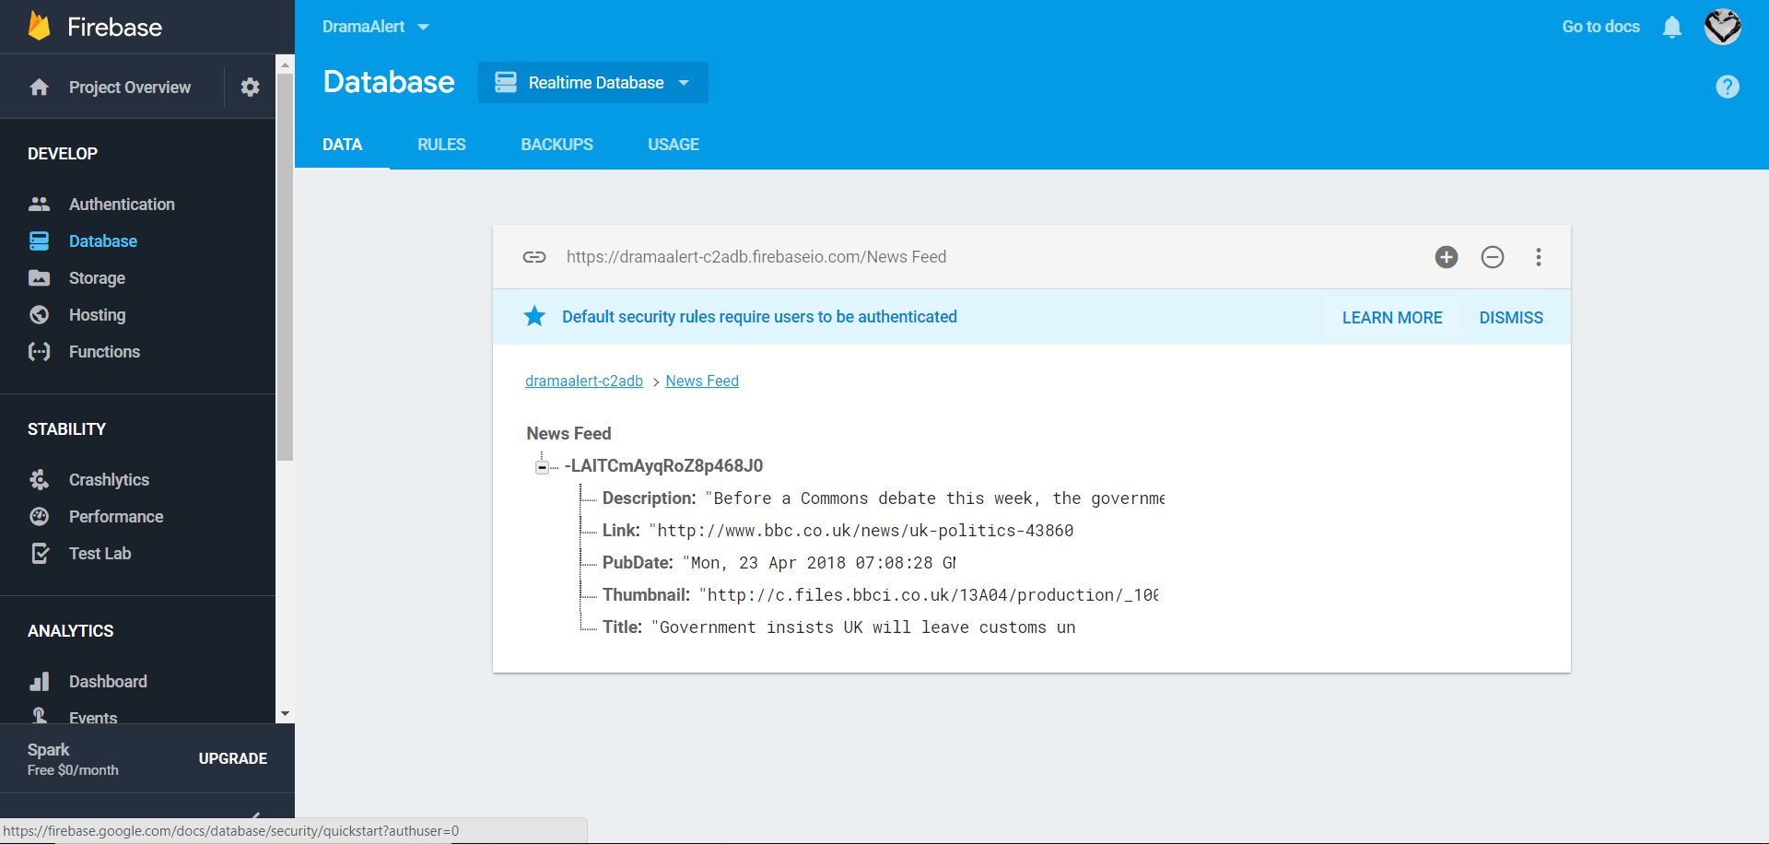

Zapier and Firebase connected to automatically retrieve new articles as they are added
and add them to app

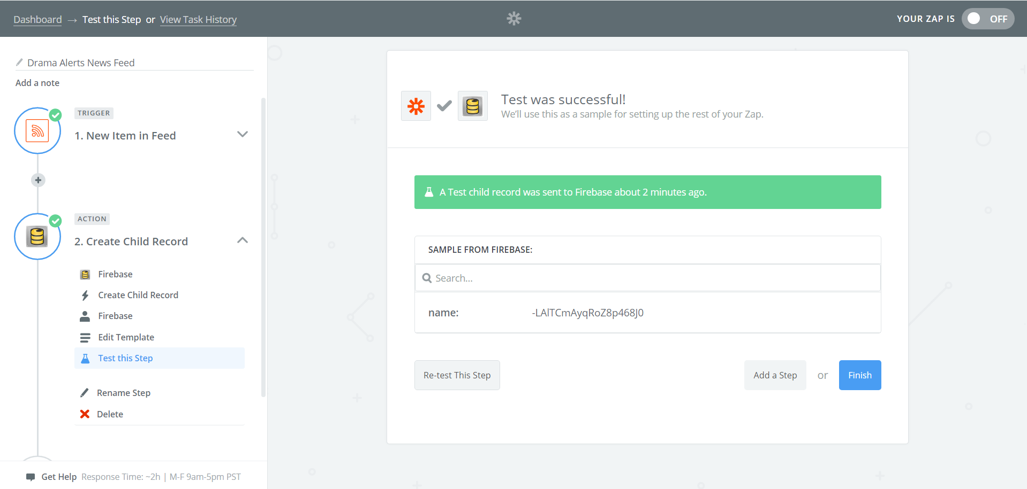
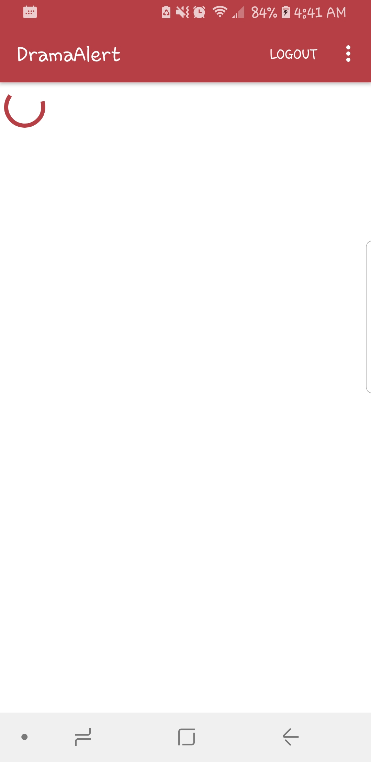 Loader screen

Sprint #6
For our first sprint, we will have the below in mind to get our app creation project started
- Create multiple access points for news information for my app and run successfully including basic info and pictures for the news.
- Save user data and provide more news stories to choose from
- Cost of implementation (story points or ideal days) will be determined as project gains motion ( project backlogs)
- Testing availability of articles and ability for users to save and customize their pages.
- Risks resolved as a consequence of implementing specific features will be updated as the project is in motion and if any are discovered during this time

The Sprint Backlog identifies stories planned for the sprint along with tasks necessary to complete each story. This list also shows what was planned for the sprint and the amount of time it took for it to be achieved.

Sprint Backlog
Story ID | Story / Task | Estimated  Hours | Actual  Hours
S3 | Fix Current Problem with loader screen | 15 | 20
 | Update/Save user info | 2 | 1
 | Add/ remove articles | 2 | 5
 | Add help section | 2 | 3
 | Debug and test | 10 | 15
S1 | Create news menu | 5 | 1
 | User guide | 3 | 4

Review
[Minutes/notes from feature demo (product review).]

Retrospective
What went well? What could have gone better? What lessons did you learn? What do you plan to do differently on the next iteration?

My previous iteration left my app crashing and I was able to find the problem of why I was stuck on the loader screen. Being the last iteration, I spent a lot more time than previous iterations to make sure it was working as desired. I was able to find that I had made an erroneous typo that was not picked up by android studio. This was pertaining to my news api. For this reason, no news was able to appear on the screen because of this incorrect info. Once I discovered this, it was easy to move on from there. I am happy to have completed a working app despite not being able to add the features I had wanted to.

I encountered a few issues using Zapier and thus decided to revert back to a general News API website where I could fetch whatever news source I was interested in. I was not able to add multiple sources, but I may have a solution that I can continue to work with. I can set several use cases and add tabs to display news from various sources using switch cases. I tried to implement this solution but due to the time constraint, I was not able to complete it and left it out of this iteration.
I also encountered a problem with the Picasso loader and thus not able to display pictures correctly. This was deliberately left out so as not to provide formats that are not uniform as they made the app look very disorganized. I decided to change the format but still included a place holder for an image file to be corrected appropriately.

I had also hoped to allow users to save articles they liked and will continue to look further into that. I realize that as one logs in the articles change and it would be great to save some articles you may not read at that time but would like to come back to.

I had set very many goals for this project in general. I do not think they were unattainable with the given timeframe, but considering the amount of coursework I was involved in, I was not able to implement some of the cool ideas I had in place. Despite the project being over, I will continue to improve on my app till I get it to where I want it to be. It was very useful to do some research before working on the project. Due to the new update a lot of resources are no longer valid so this was a bit of a problem none-the-less.

Project velocity:
I planned to complete two stories that were worth 39 story points. My project velocity is 49. I was able to successfully complete the app despite not adding all desired features as expected. The most important aspects of the app are fully functional and working correctly. Only improvements can be made now.
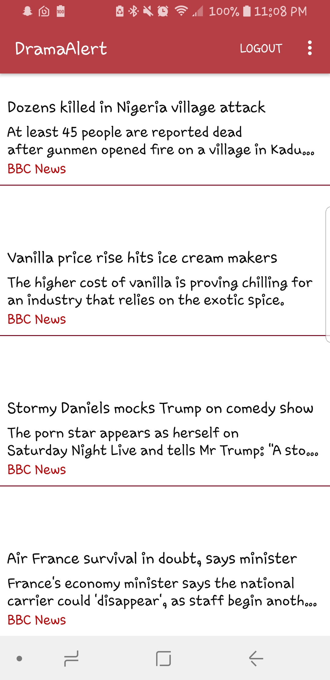 Drama Alert News Loaded
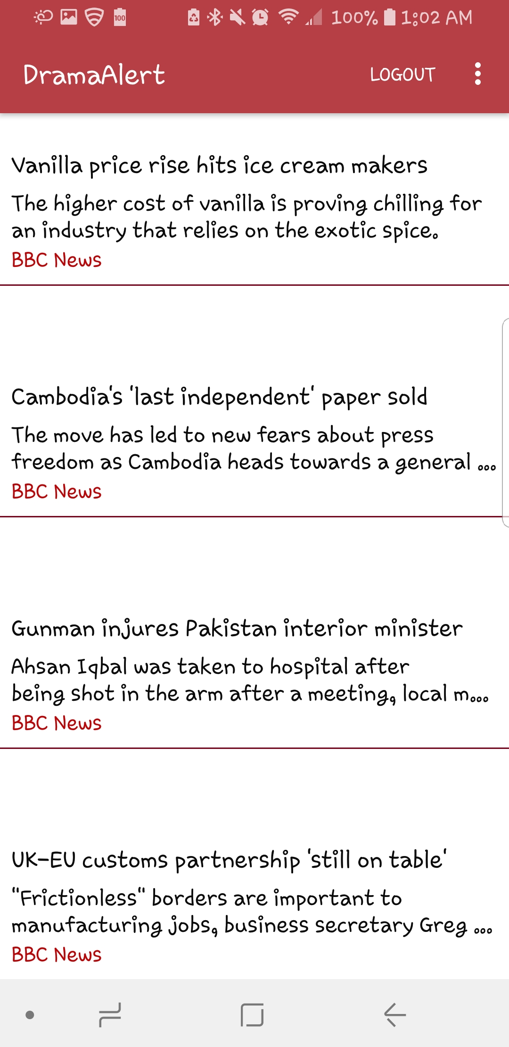 News stories updated after logging in again
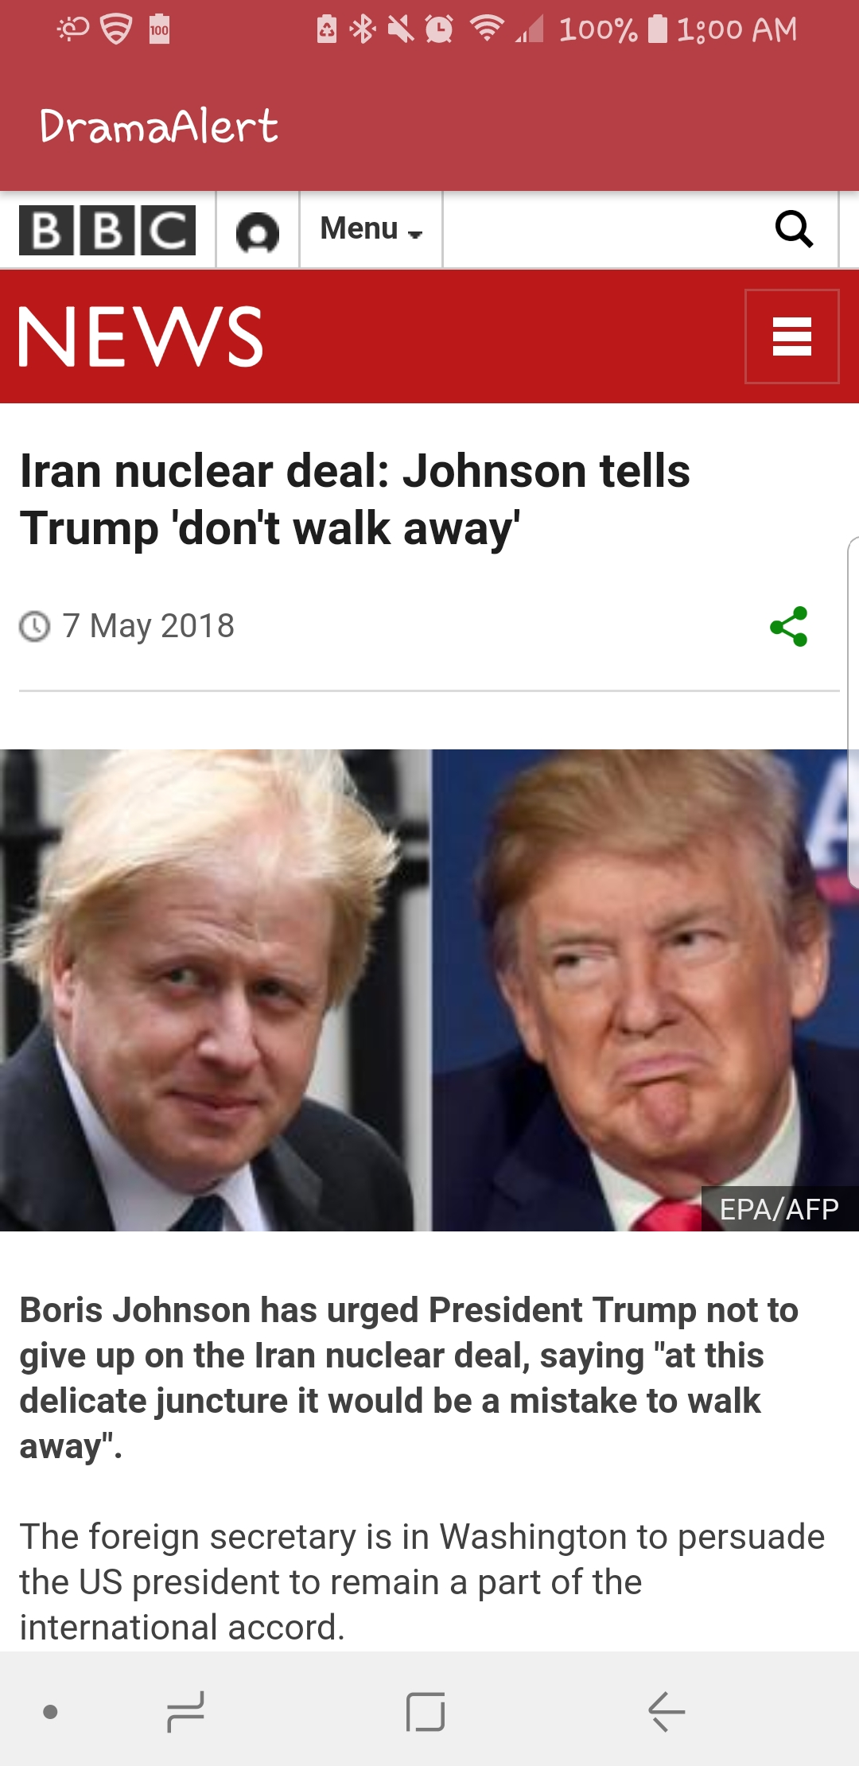 News Story through BBC on Drama Alert app (Example)

Design
My app is designed to where in order to access any of the information, you are required to register if not already a user and then login to access all the information necessary. Through the use of an API key, I am able to display news stories from a specific reliable website (BBC NEWS) that user can find useful articles displayed using a short description that they can click on to read more on the stories.
There are some additional pages such as Learn More for new users to read about before making the decision to register and eventually use the service. Registrations are stored in firebase where I can keep track of current users as they register for the service. This also is used to verify logins and prevents 3 incorrect attempts.
The layout of the app is fairly simple and that leaves space for additional improvements and additions to news sources or a tracking method for users.

Coding Standards
Coding standards improve readability. They make it easier to understand code written by others. Good coding standards also improve reliability.

